**DA1**

**Execution time at 16MHz/#cycles:**

1,751.56 us/28,025 = 62.5 ns

**Flowchart of assembly code:**

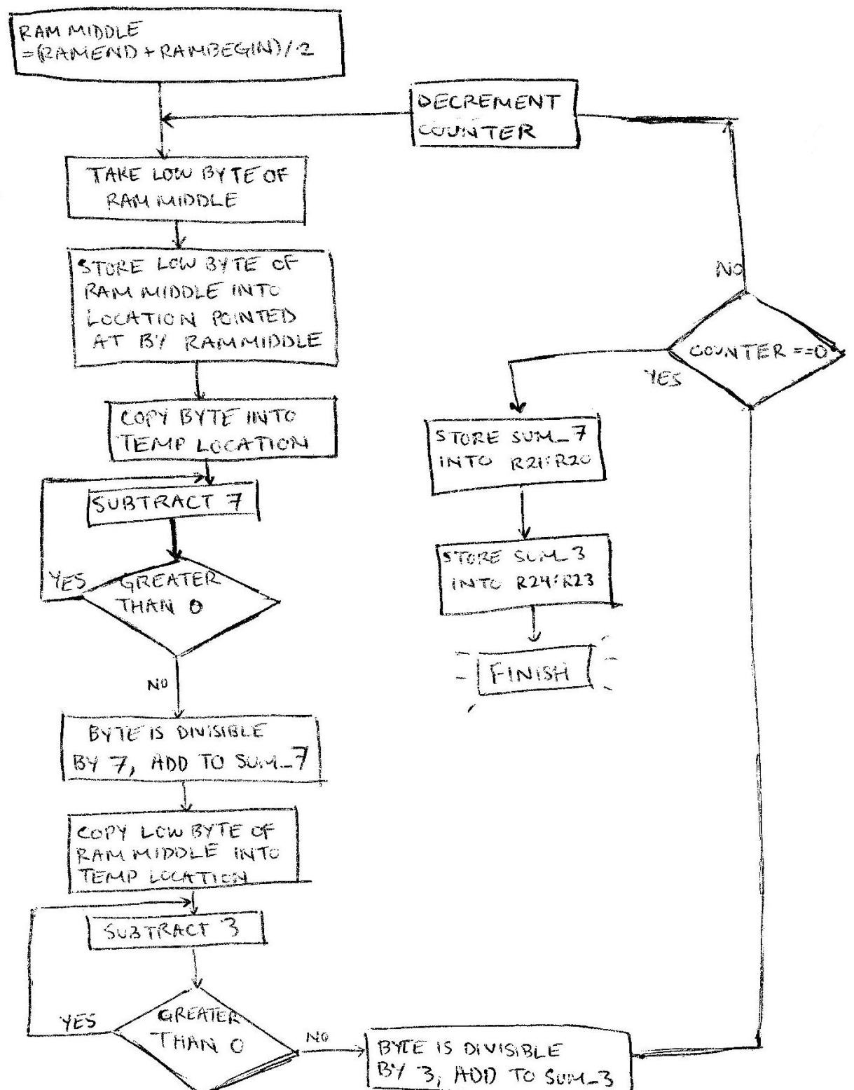

**Screenshots**:

RAM MIDDLE with 25 numbers stored, starting at 0x04AF

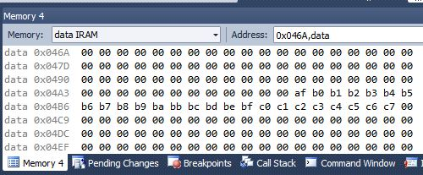

Processor state after simulation

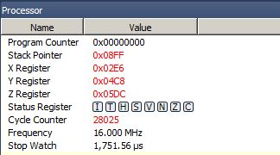

Register contents after simulation

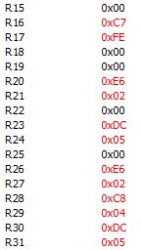

🡨 R20:R211 contain sum of numbers divisible by 7

🡨 R24:R23 contains sum of numbers divisible by 3

🡨 Y points at RAM locations starting at 0x04AF and ending at 0x04C8